**Modern Education Society’s  
College of Engineering, Pune**

|  |  |
| --- | --- |
| **NAME OF STUDENT:** Prathamesh Kalyan Sable | **CLASS:** SE Comp 1 |
| **SEMESTER/YEAR:** Sem-3 / 2022-23 | **ROLL NO:** 015 |
| **DATE OF PERFORMANCE:**  / /2022 | **DATE OF SUBMISSION:** / /2022 |
| **EXAMINED BY:** | **EXPERIMENT NO: DSL B-14** |

**TITLE: SORTING OPERATIONS**

**PROBLEM STATEMENT:** Write a **Python** program to store first year percentage of students in array. Write function for sorting array of floating point numbers in ascending order using

1. Selection Sort
2. Bubble sort and display top five scores.

**OBJECTIVES:**

**1.** To understand structure of Array.  
 **2.** To understand how to sort elements of given array.

**OUTCOME:** 1. To operate on the various structured data.  
 2. To analyze the problem to apply suitable algorithm and data structure.

**PRE-REQUISITES:**

**1.** Knowledge of Python Programming  
 2. Knowledge of sorting methods and array.

**APPARATUS:**

Computer Machine, python3 installed, etc.

**QUESTIONS:**

1. Explain Merge sort with example and write C++ program for same.

**SOURCE CODE:**

1. Selection Sort

def **selection_sort**(arr):

    n = **len**(arr)  *# size of array*

    for i in **range**(n):  *# for each index*

**min** = i  *# default minimun to i th index*

        for j in **range**(i+1, n):

            if arr[j] < arr[**min**]:

**min** = j

        if **min** != i:  *# swap min with i*

            arr[i], arr[**min**] = arr[**min**], arr[i]

arr = []

n = **int**(**input**("Enter Number of Students:"))

for i in **range**(n):

    arr.**append**(**float**(**input**(f"Enter Percentage of Student{i+1}:")))

**print**("Array of Percentage is : ", arr)

**selection_sort**(arr)

*# top five scores using reverse indexing*

**print**("Top five Scores are : ", arr[-1:-6:-1])

1. Bubble Sort

def **bubble_sort**(arr):

    n = **len**(arr)  *# size of array*

    for i in **range**(n):  *# for each index*

        for j in **range**(0, n-i-1):

            if arr[j] > arr[j+1]:

                arr[j], arr[j+1] = arr[j+1], arr[j]

arr = []

n = **int**(**input**("Enter Number of Students:"))

for i in **range**(n):

    arr.**append**(**float**(**input**(f"Enter Percentage of Student{i+1}:")))

**print**("Array of Percentage is : ", arr)

**bubble_sort**(arr)

*# top five scores using reverse indexing*

**print**("Top five Scores are : ", arr[-1:-6:-1])

**OUTPUT:**

1. Selection Sort

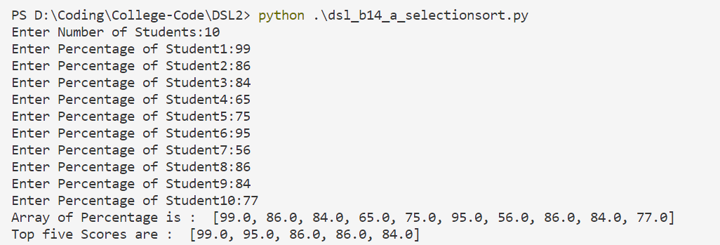

1. Bubble Sort

